

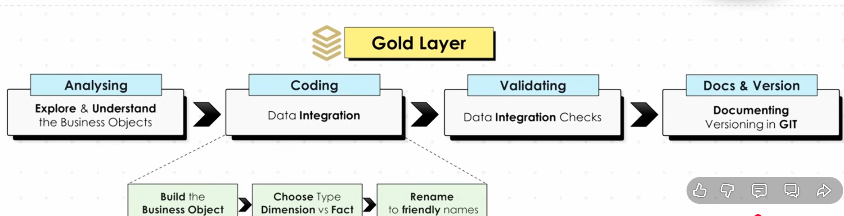

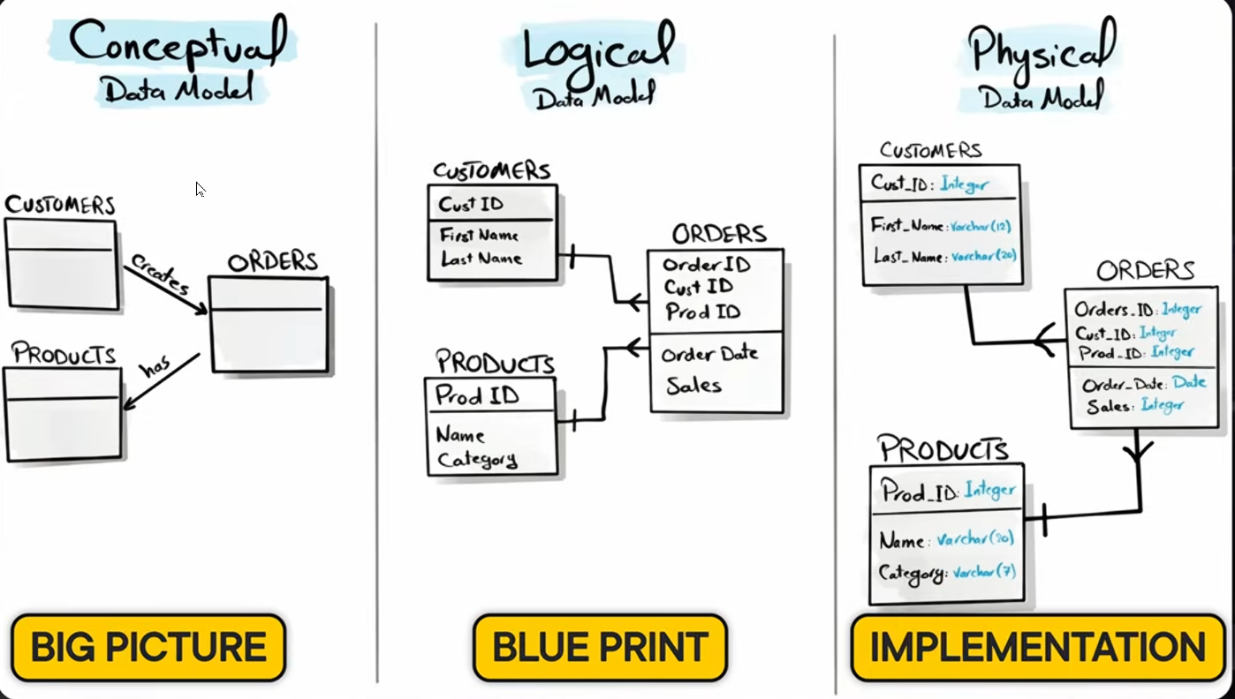We are going to make the logical data model

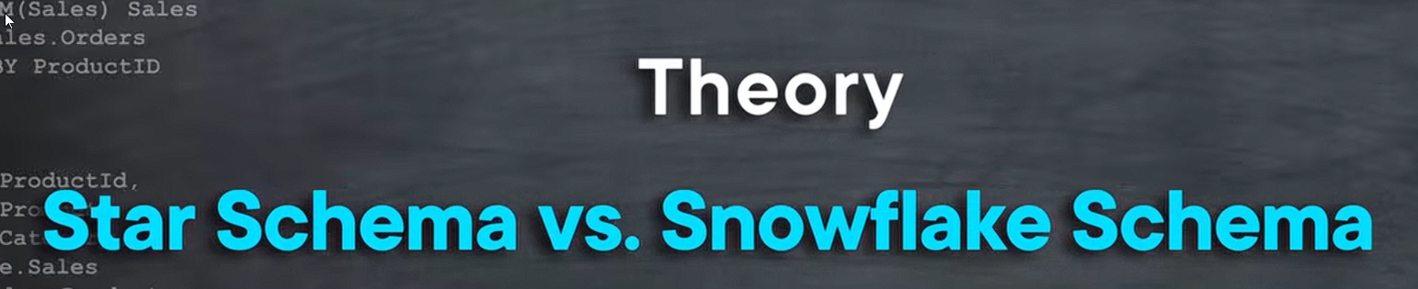

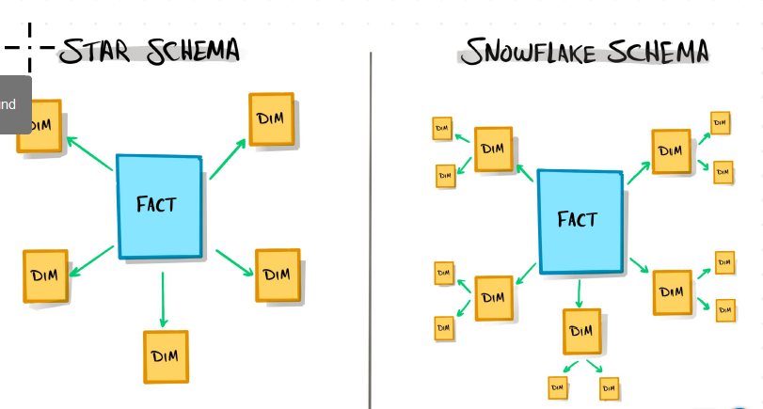

We are going to use star schema

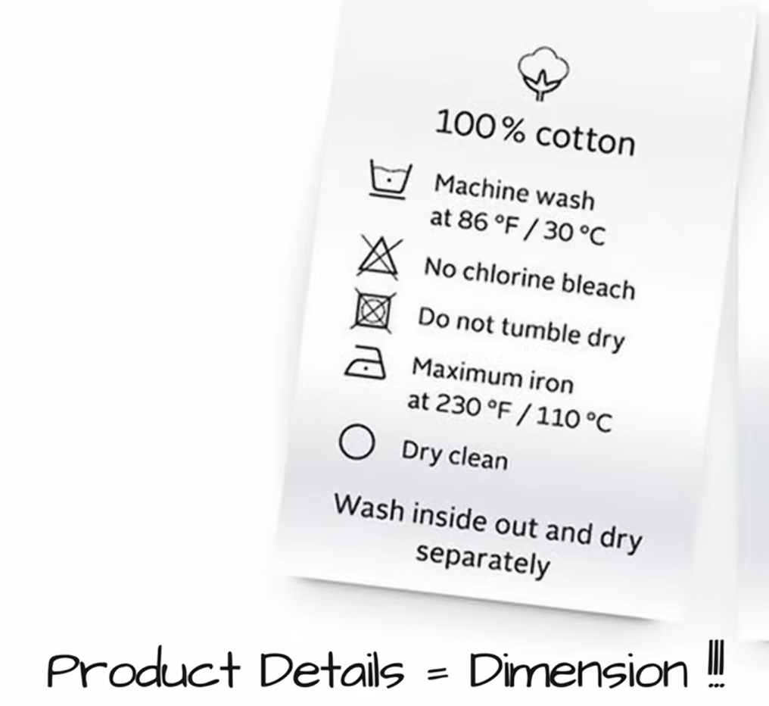



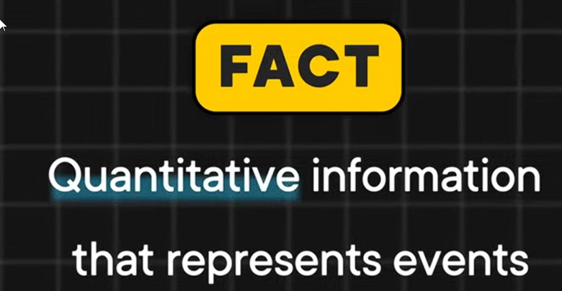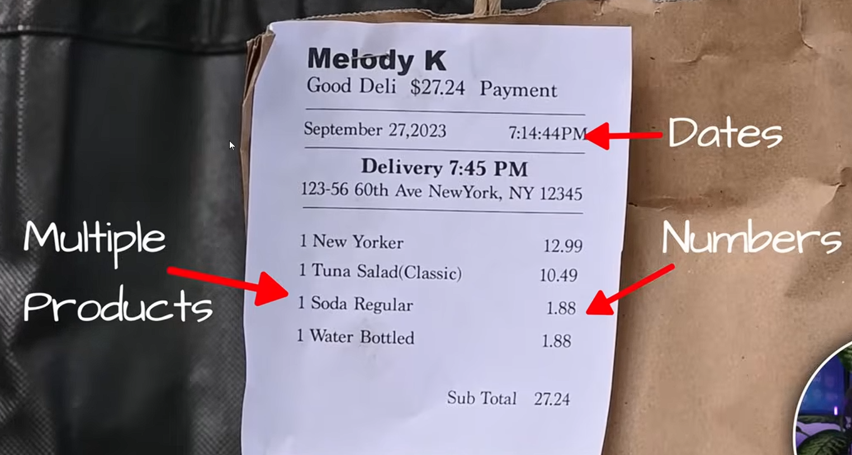

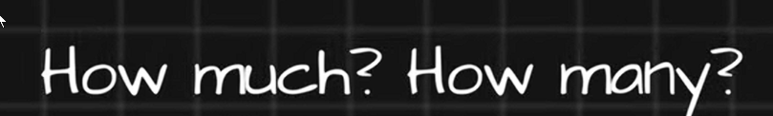

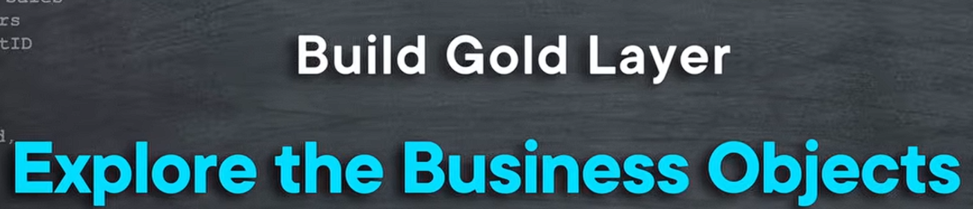

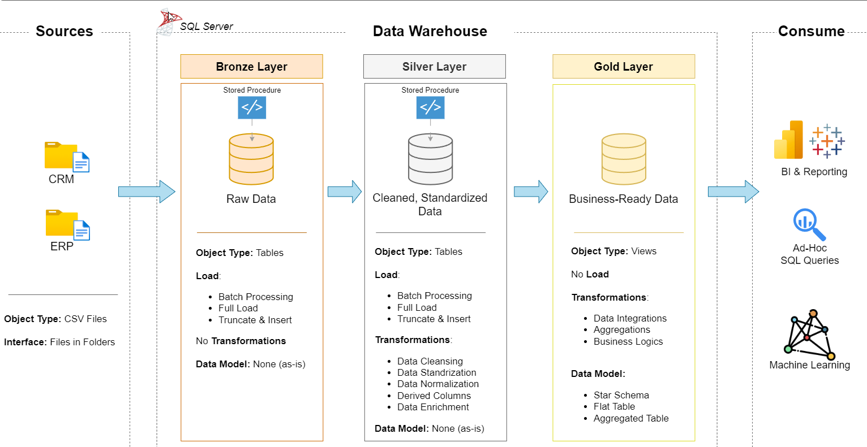

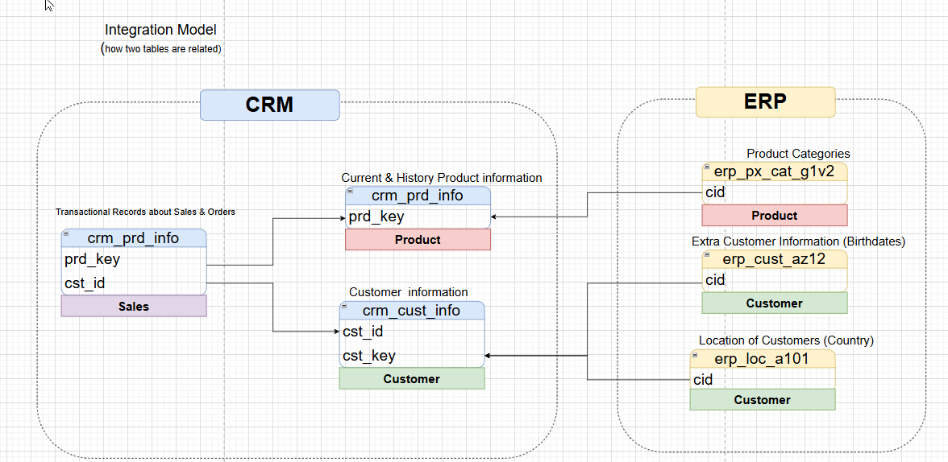

Let's start with the customer table

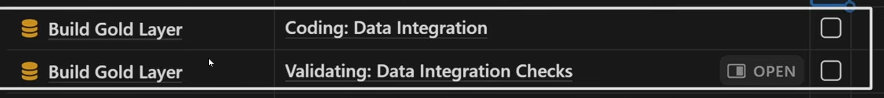

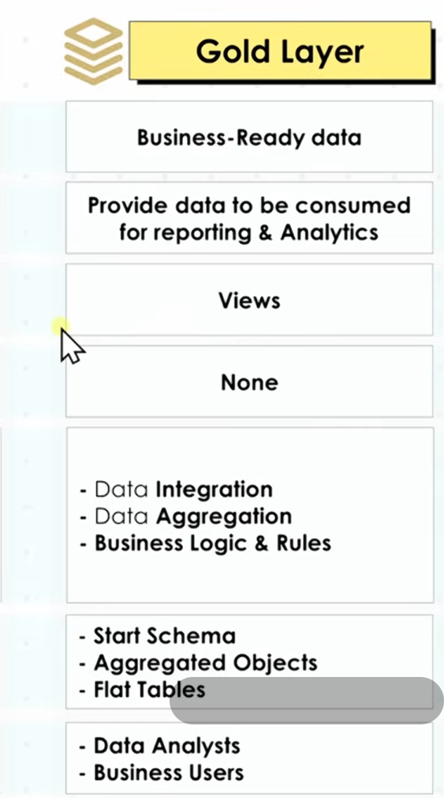

Now we're going to collect data from the Silver Layer. The silver is already clean.

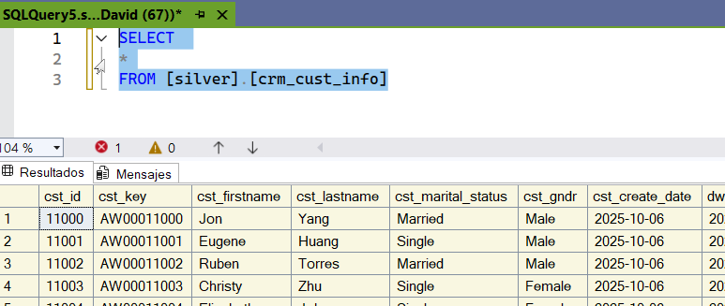

Let's choose the columns that will be displayed in the golden layer.

I'll give the table an alias.

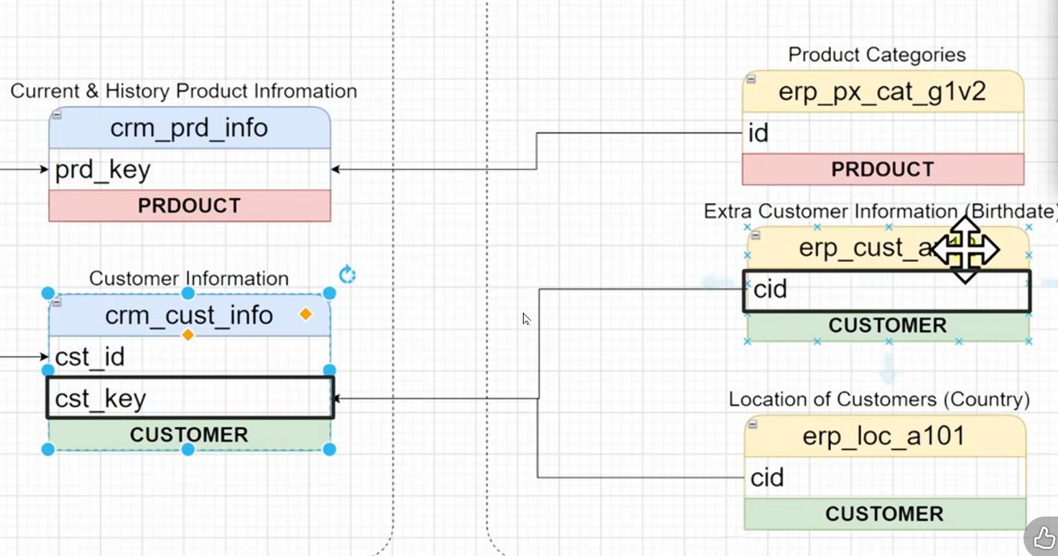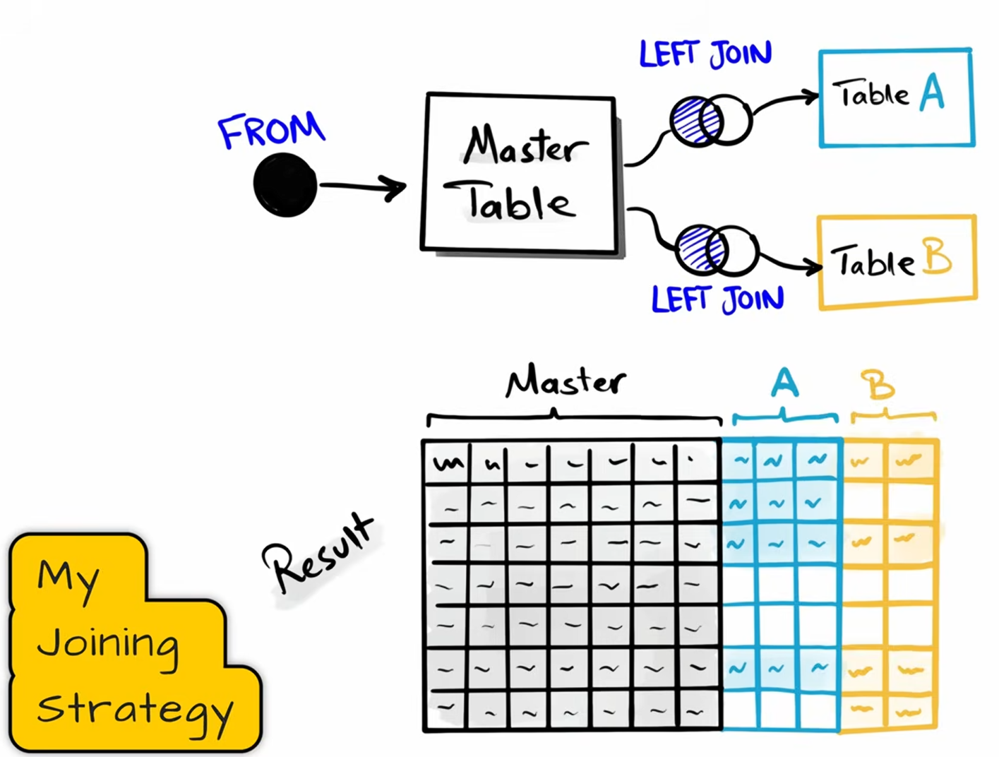

We need to join the data with the CID and the customer key. Avoid the inner join.

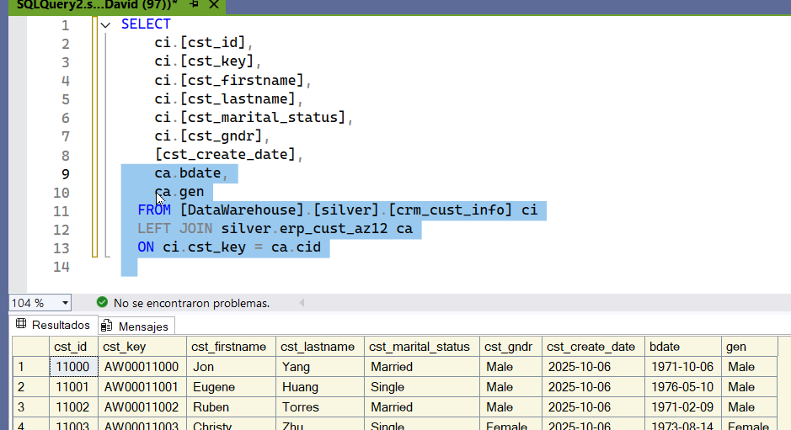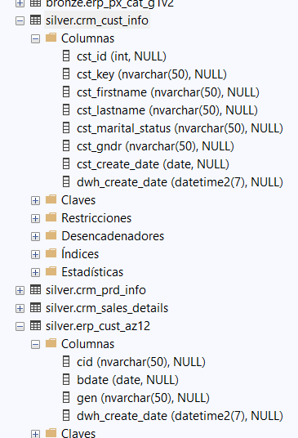

we join these two tables.

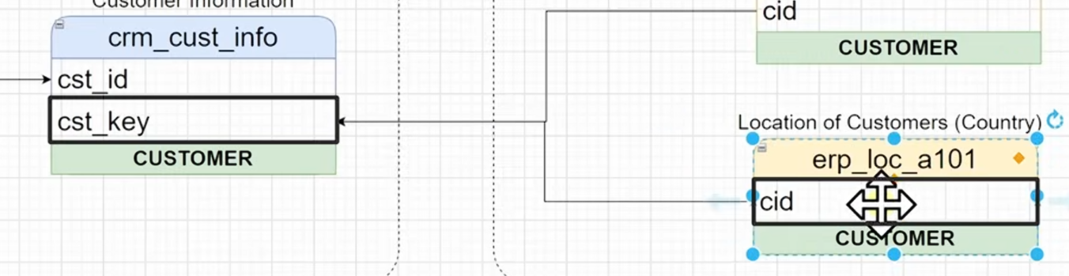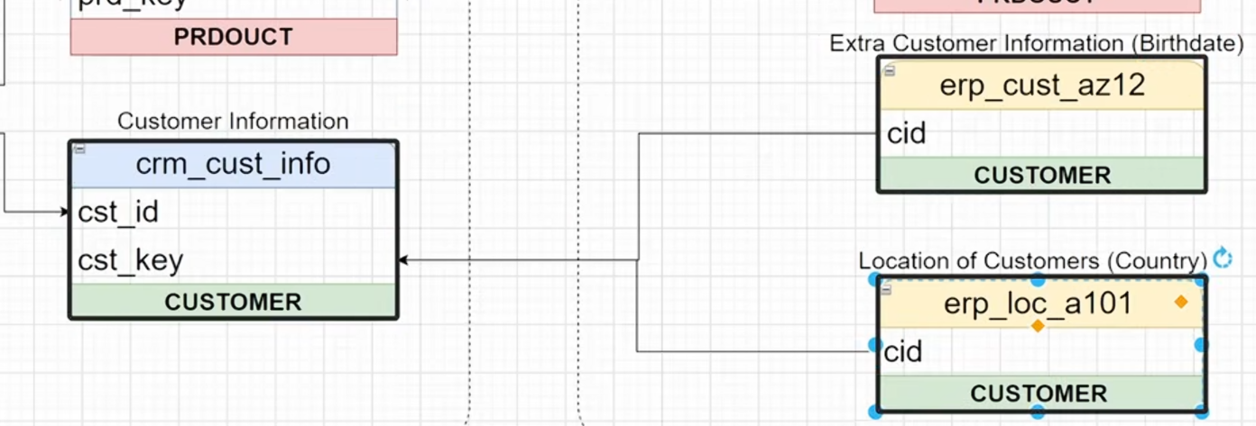

we connect to the other location information table with key

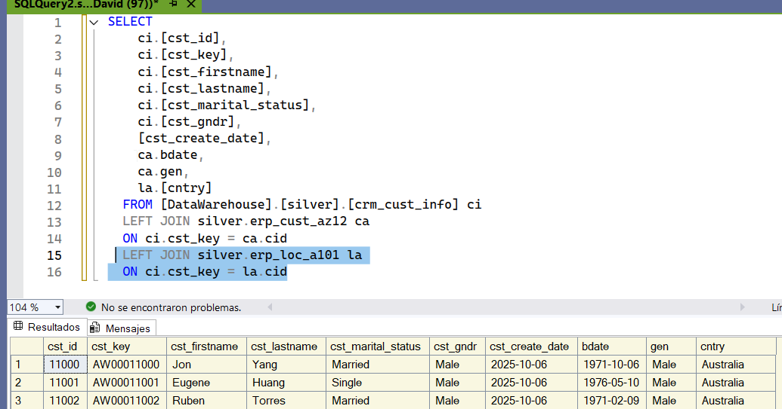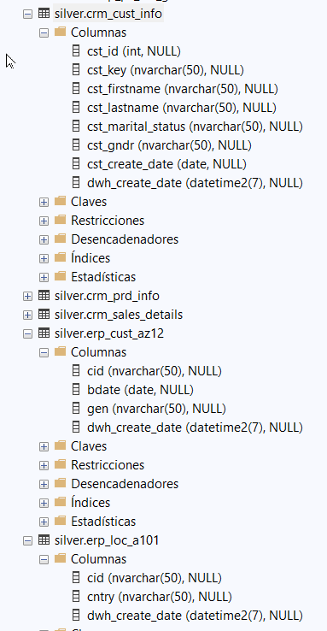

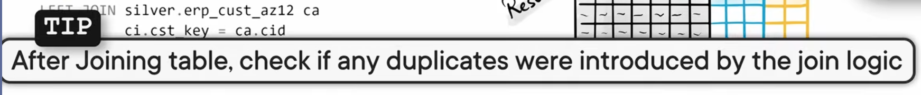

Let's check if there are duplicates in the query using group by

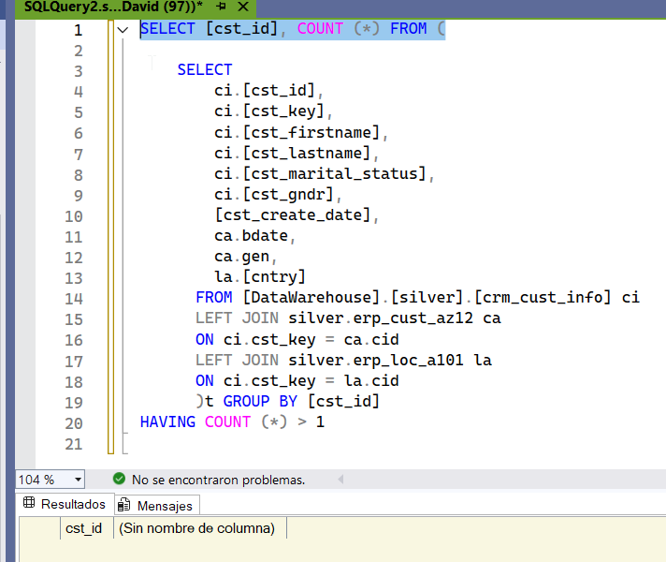

This query is used to see if we have duplicates in the PK.

This means that after joining all these tables, there is no problem.

We have a problem because we have two sources of gender information. One comes from ci.cst_gndr and the other from ca.gen

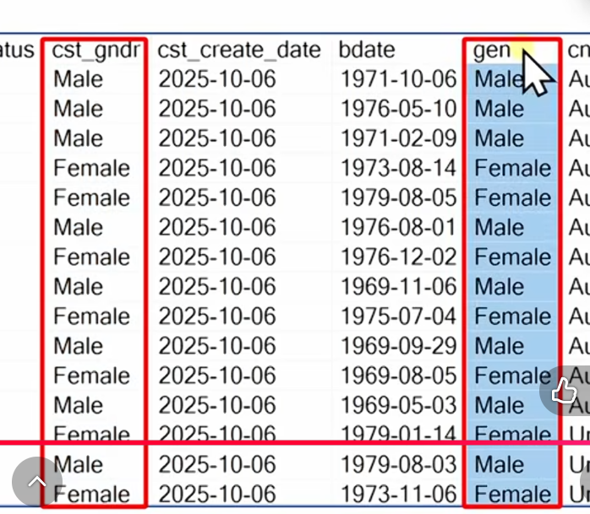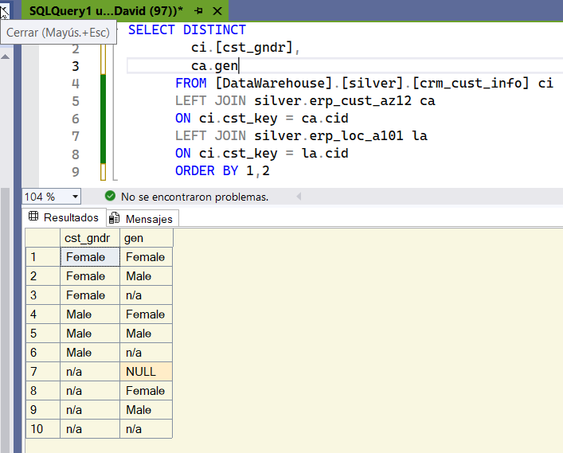

We need to do data integration. We'll remove all the information and leave those two columns. We'll leave only DISTINCT.

We have all the scenarios.

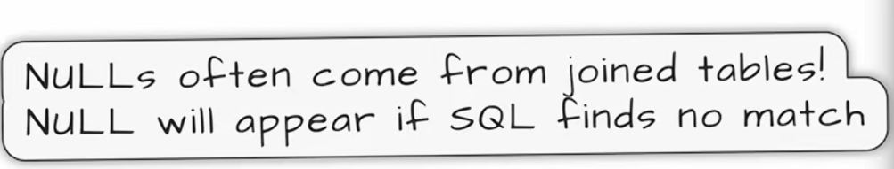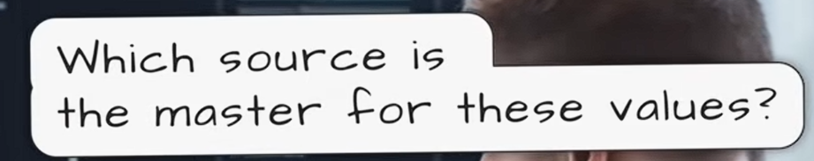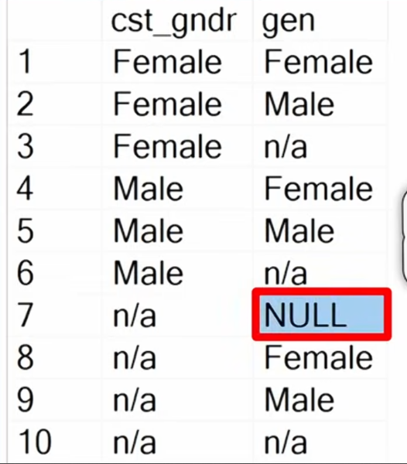

The NUll comes from joining tables.

That means there's a customer table and a crm table that aren't available in the other tables.

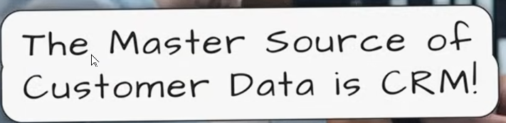

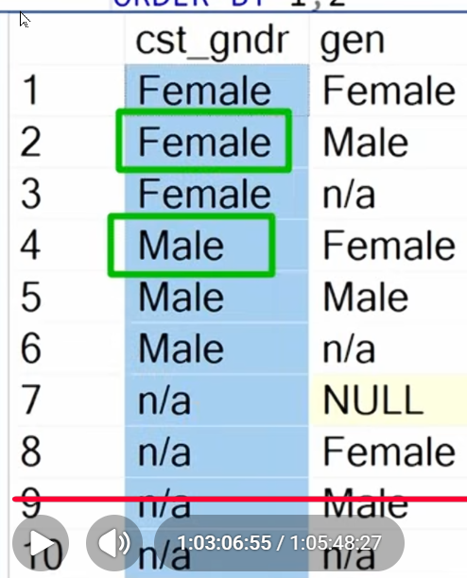

this source system is the master. -- CRM is the MAster for gender info

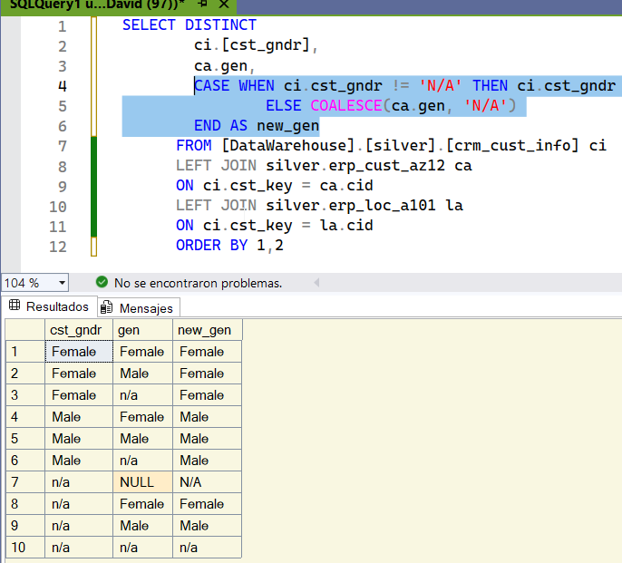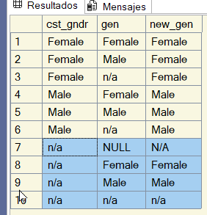

If we have data from the CRM system we have to use it is not equal this means its not available (this means we dont have a value female or male) then go and used it. Otherwise that means if its not available then go and use the information fro mnthe second table. We have to deal with the NULL we use the COALESCE if this is a null then N/A. So when we have a null it will say NA.

Since we do not have information in the first table, we use the second table. We have a beautiful new column where we integrate 2 source systems in one.

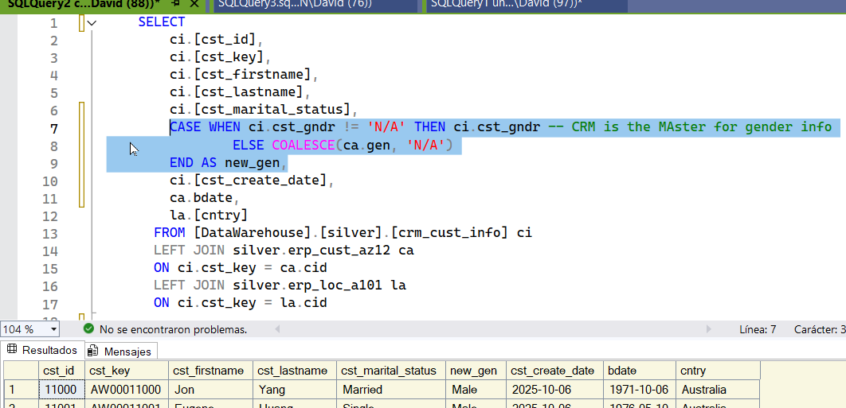

I joined those two tables with the when statement and then replaced it in the main query.

We have no duplicates. We took three tables and put them in one object.



Now we are going to give it friendly names.

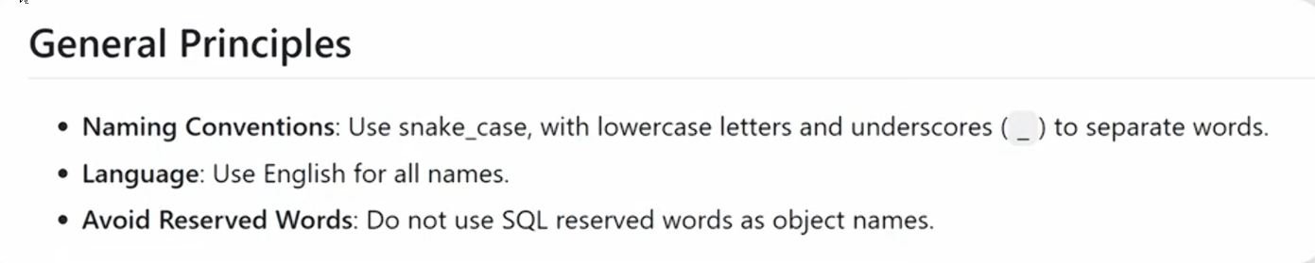

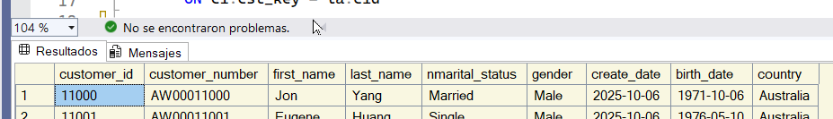

We changed the names to more friendly ones



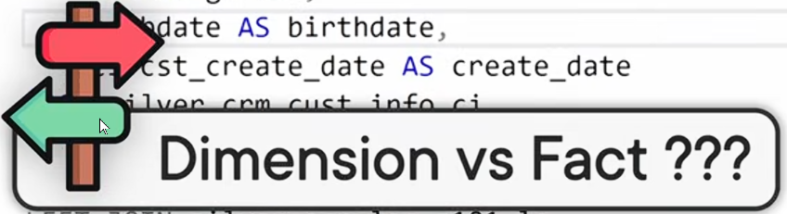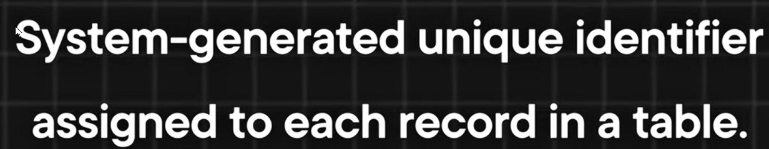

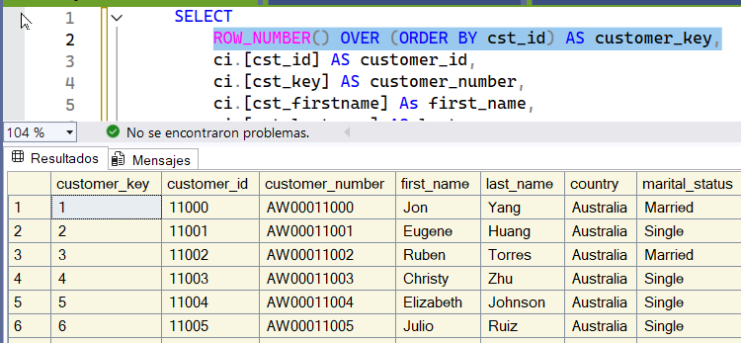we are going to use a windows function ROW

now we can use this key to connect the data model.

Now we need to create the object

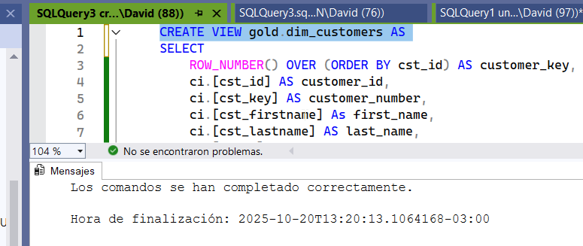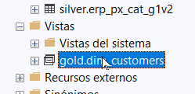

our first object



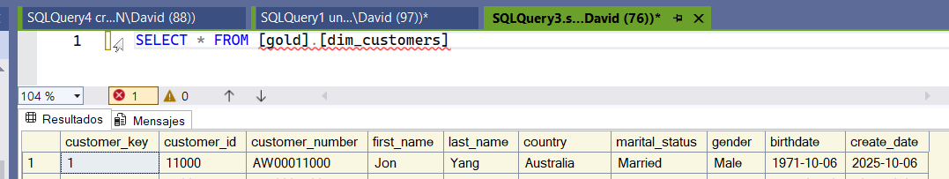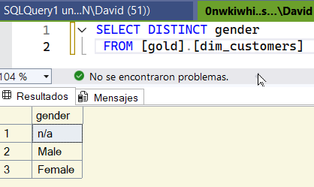

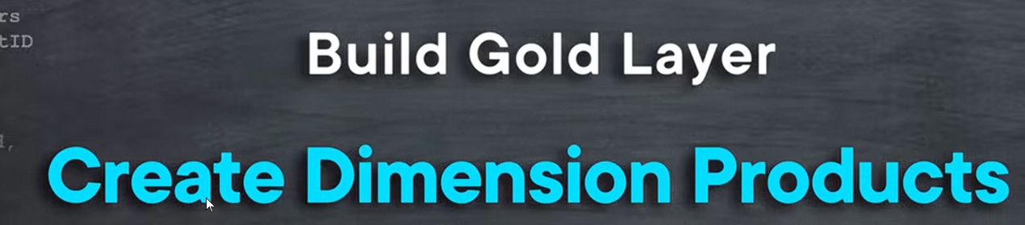

Now we have to build the 2nd object

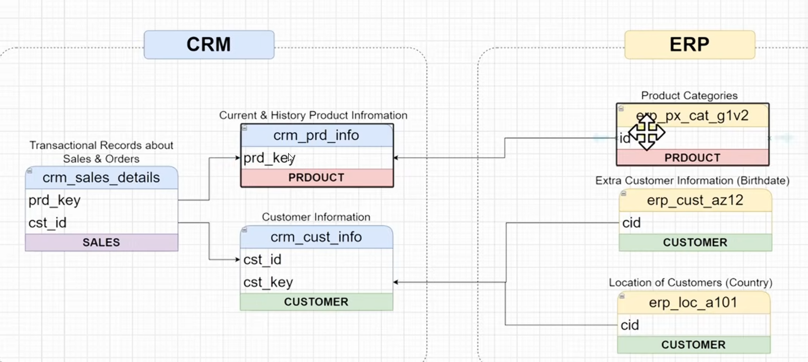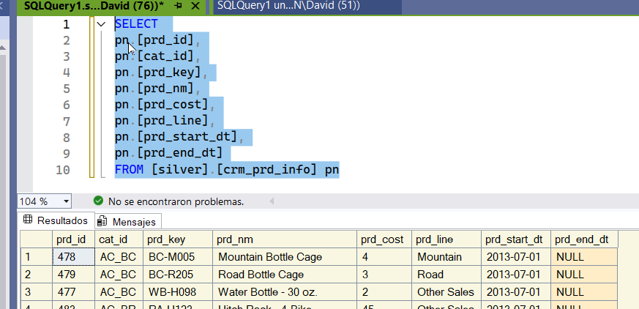

this obj contains historical info as well as current information. We are not using the primary key we are using the product key. We need to filter the historical data and stay with only current data.

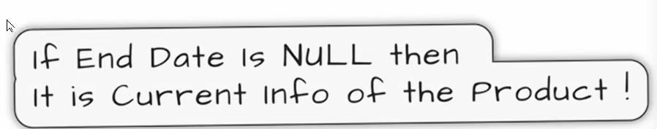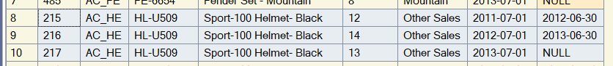

if the end date is null thern that means is the current data

we have the same pd but the first two we have a data but in the last we have null bcs is the current info. This means that it is open and its not closed yet.If we want only the current information its simple.

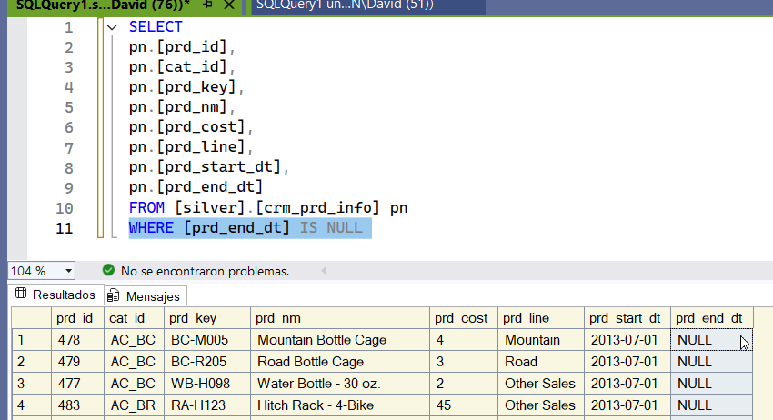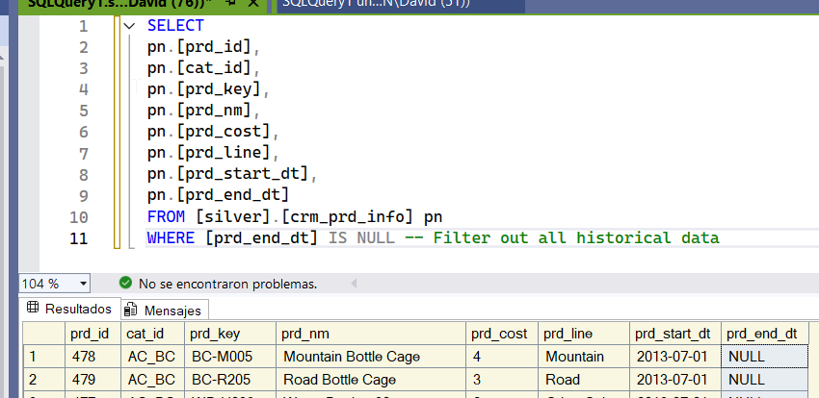

you will only have the current product. Now we dont need the end date bcs its all null

now the next step is joined the the product categories. from the erp. We are going to use the id

you will only have the current product. Now we dont need the end date bcs its all null

now the next step is joined the the product categories. from the erp. We are going to use the id

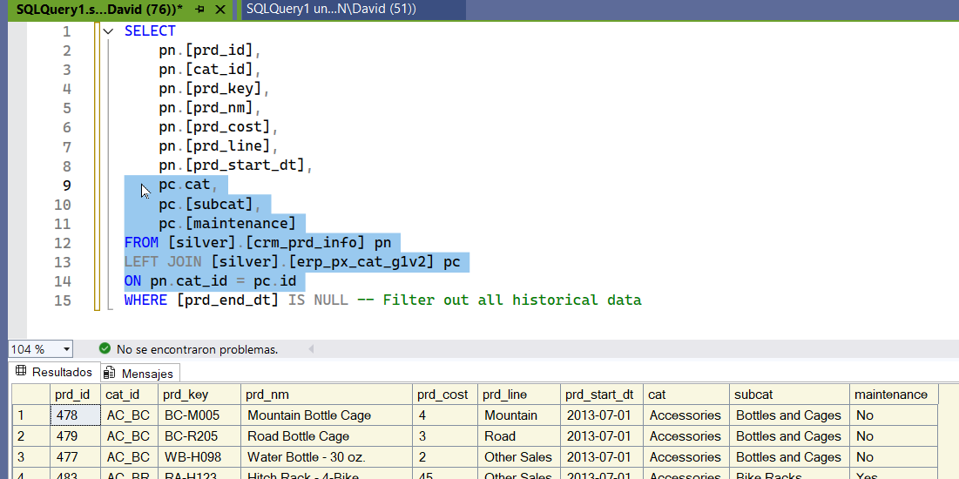

now we joined the tables

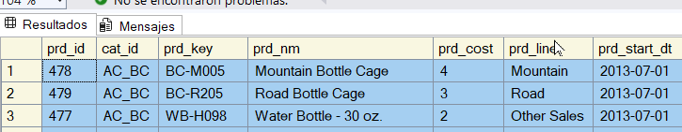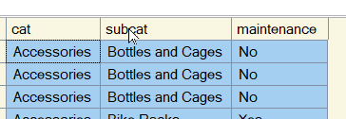

first table and second table. Now we have collected all the product information from the 2 systems. Now we need to check the quality of this results.

we want to make sure the product key is unique bcs we are going to use it later in order to join it with the sales.

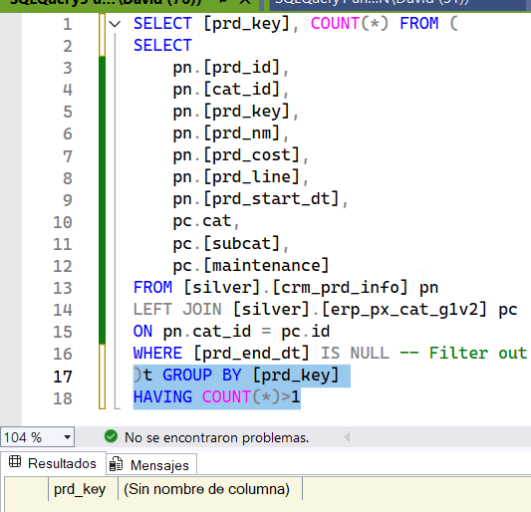

We check that the PRD key is not duplicated. We don't have any duplicates.



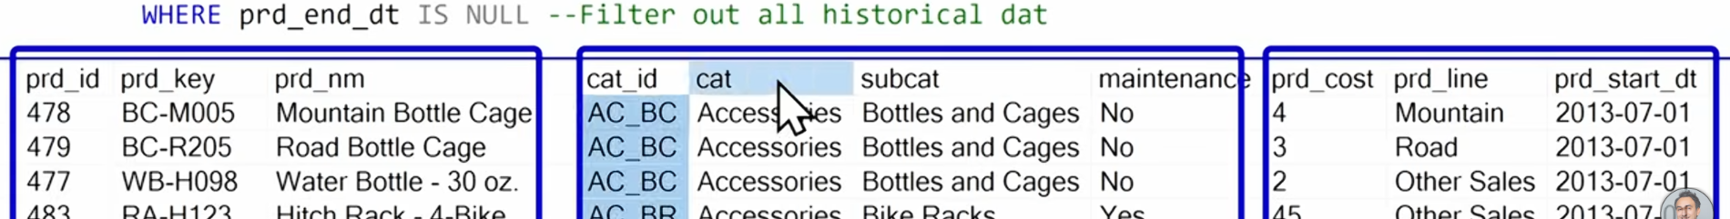



because this is a dimensio we need to create a PK we are going to use the wx fx row nm

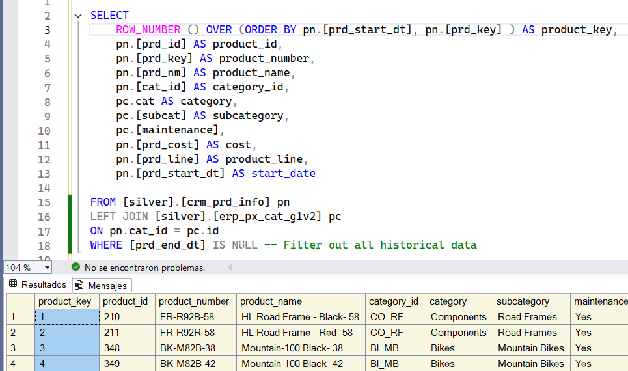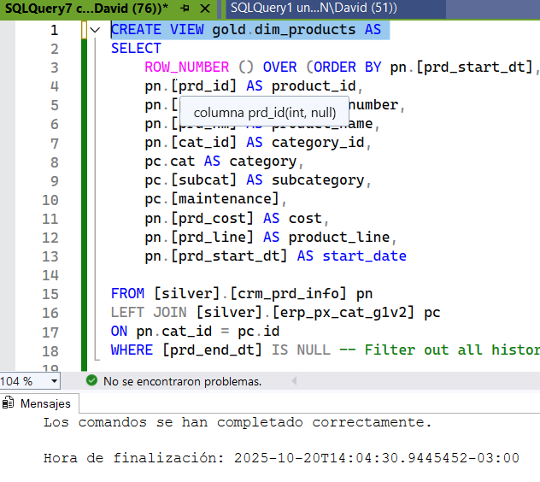

now we have generated it a pk for each product. And we are going to use it in order to connect to our data model,

Now latest build the view

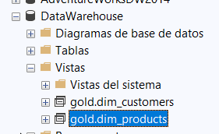

We have created our object. Gold layer 2nd dimension products

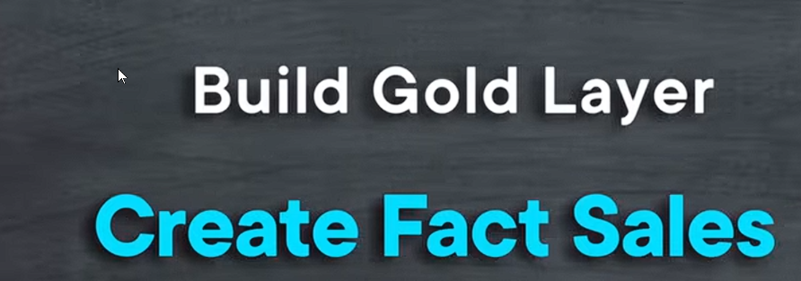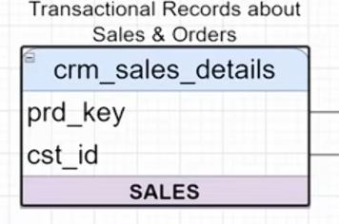

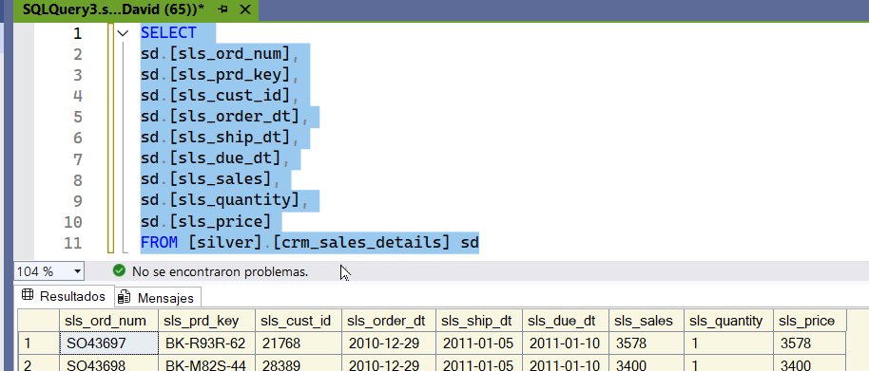

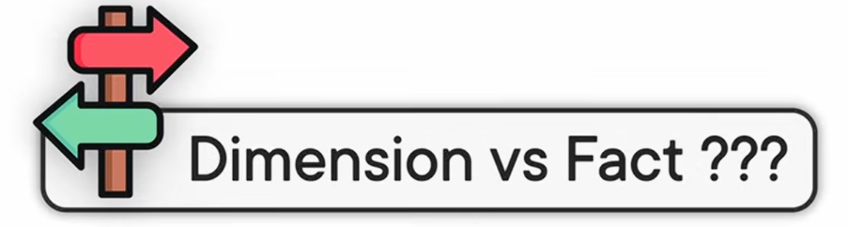

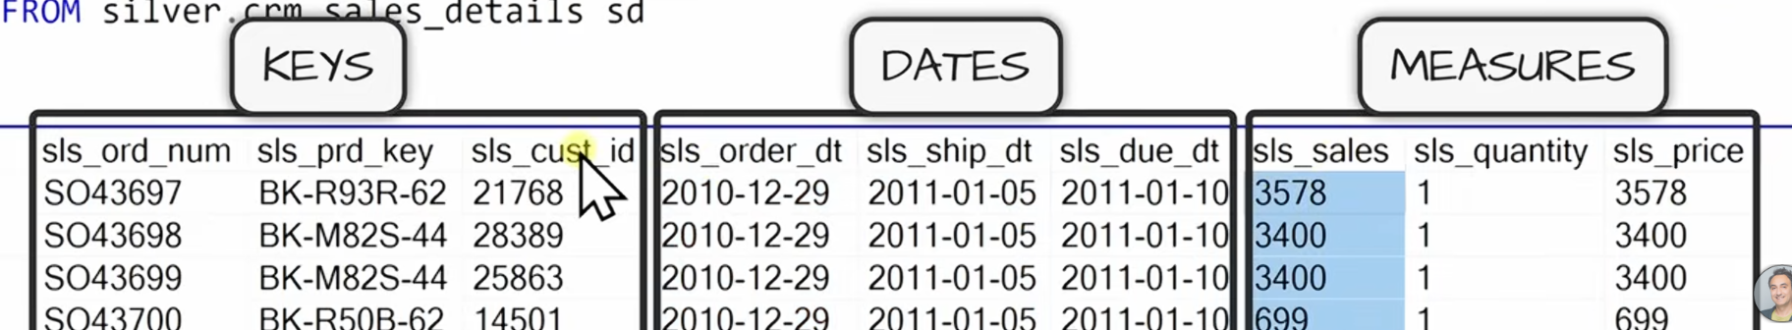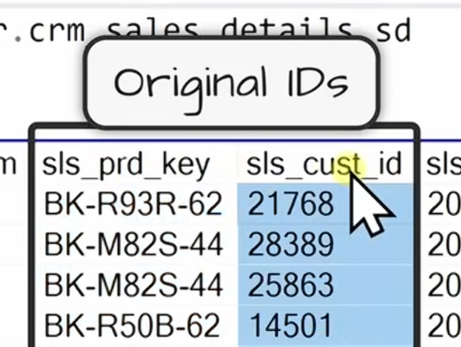

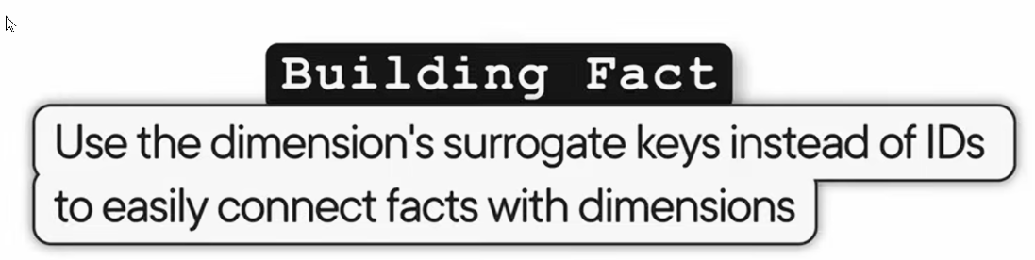

we are going to join both dimensions in order to

the prd key and the customer id those information comes from the source system we are going to replace those 2 information with the surrogate key that we have generated it. DATA LOOK UP. in the silver layer we don't have any subrogate keys we have in the golden layer. the only information that we need from the dimension is the key

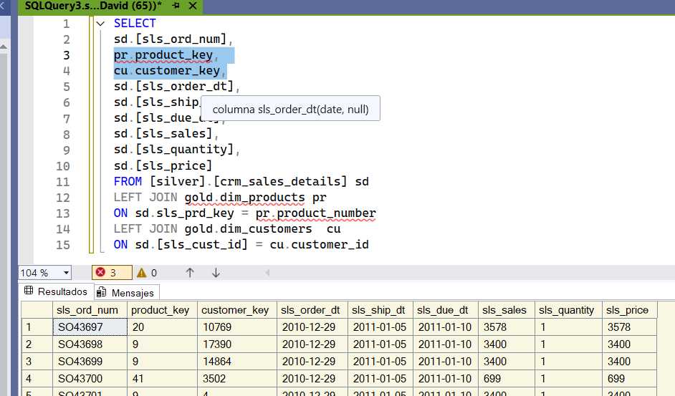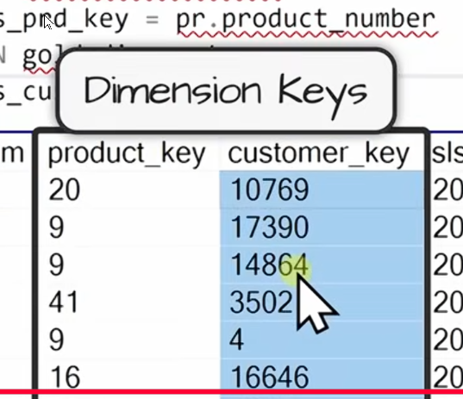

In this way we join the tables with the surrogate key that we created and delete the ones that come by default.

In our fact table we have the 2 keys from the dimension ans this will help us to connect the data model to connect the fact with the dimensions. Now we give them friends and names

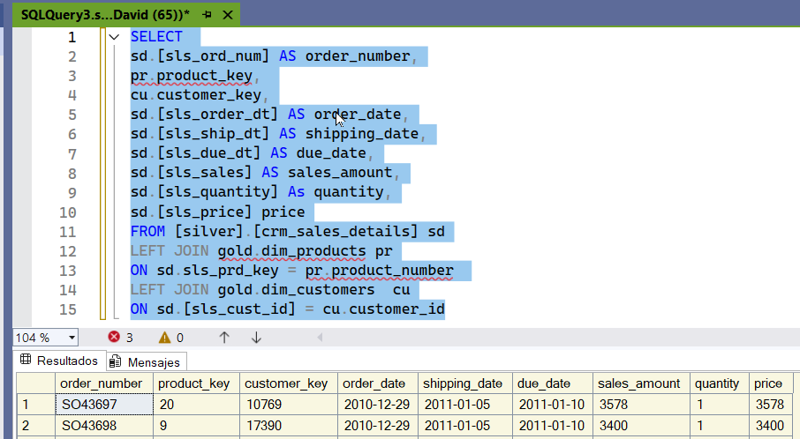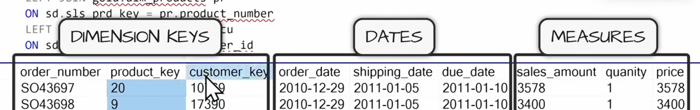

they have friendly names.

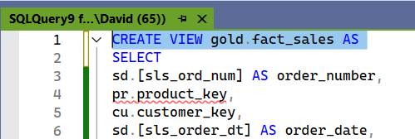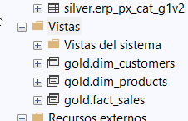

now we have 3 object in the gold layer. 2 dimension and 1 fact

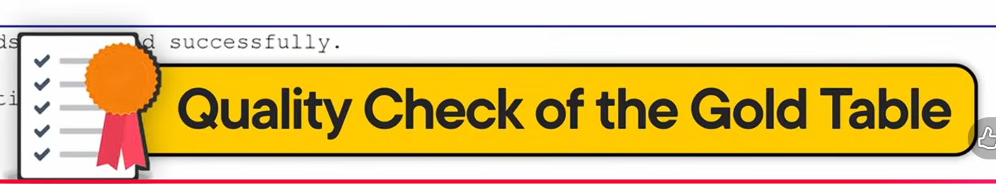

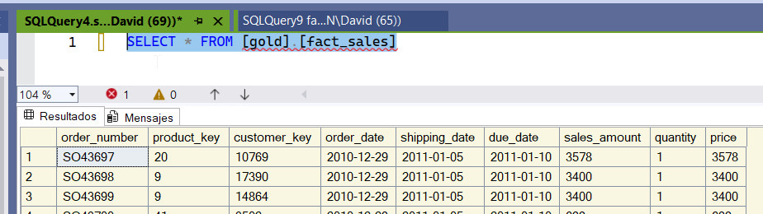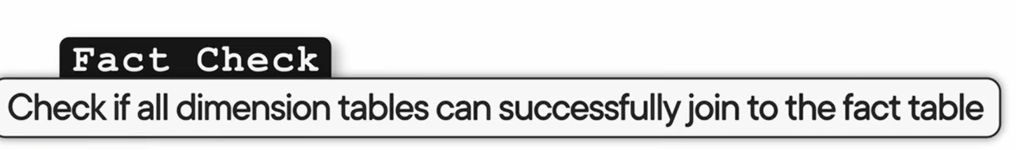

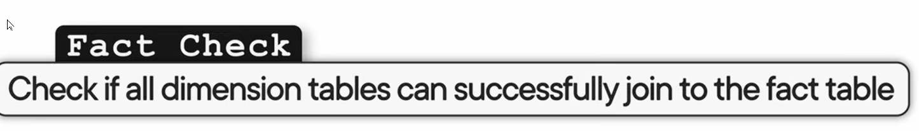

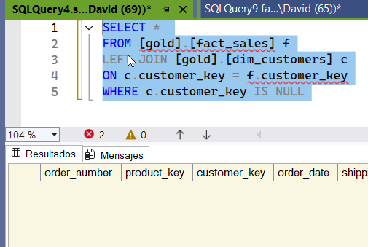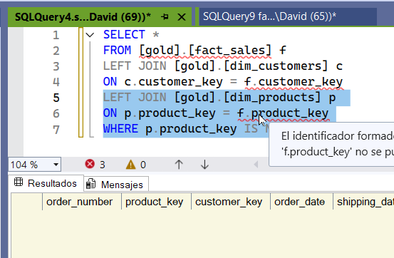

everything is matching perfectly.

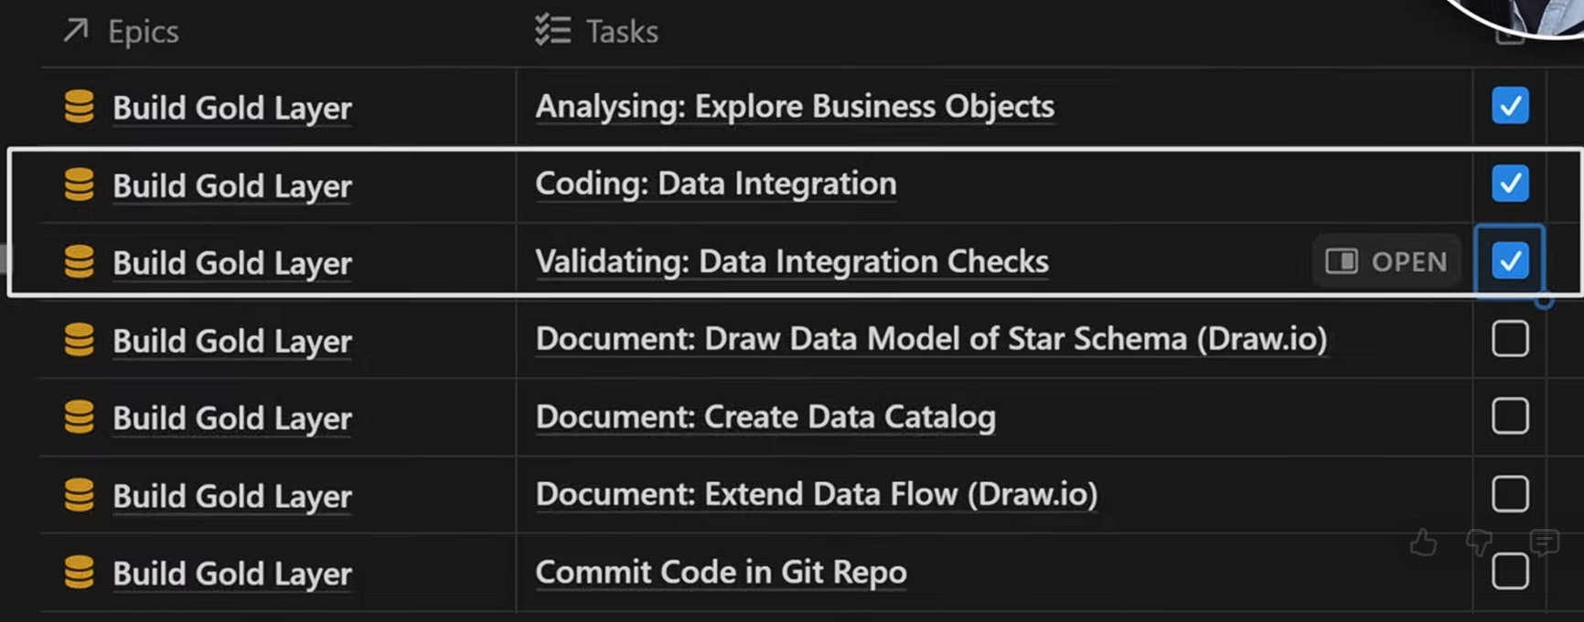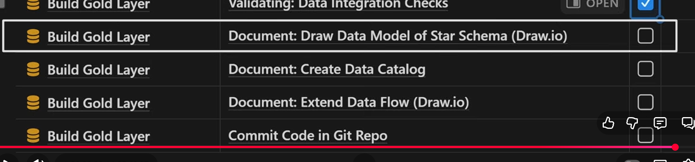

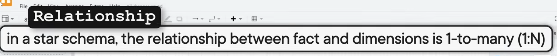

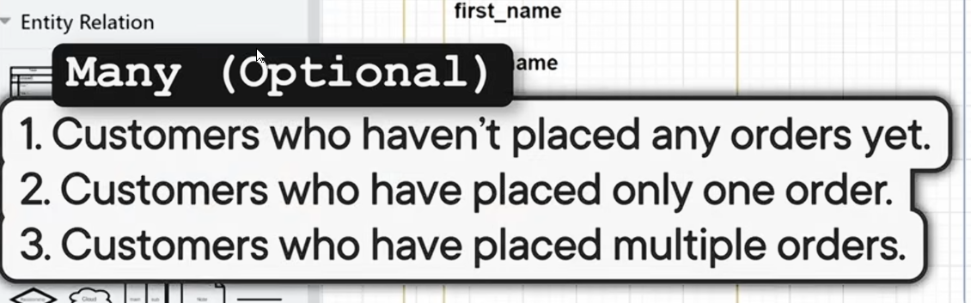

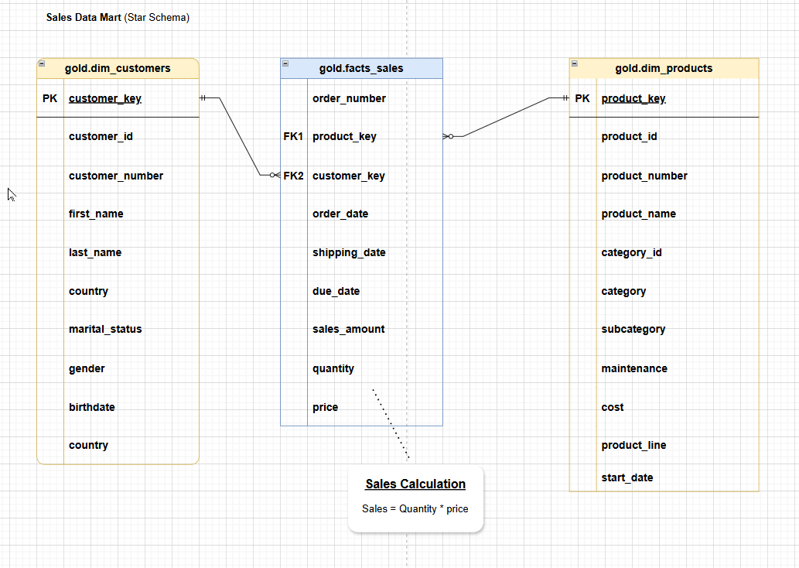

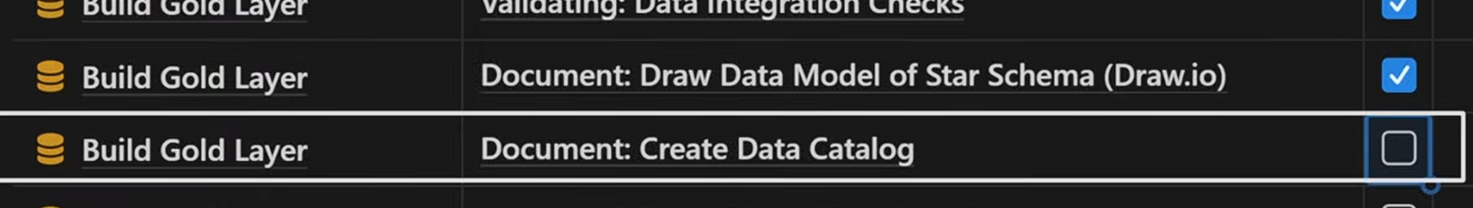

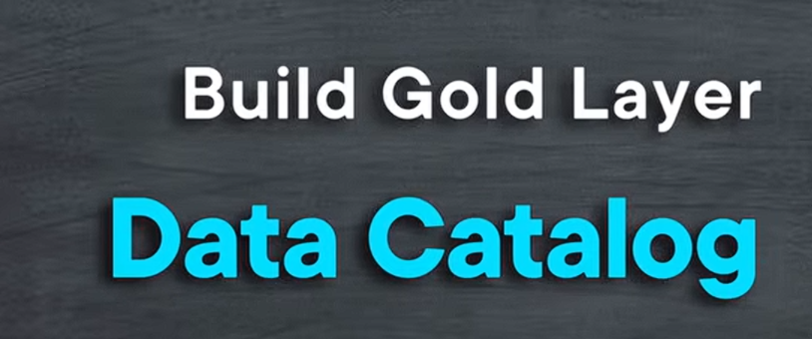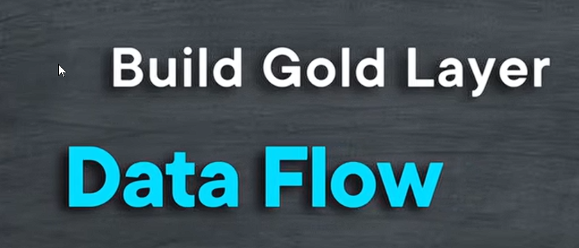

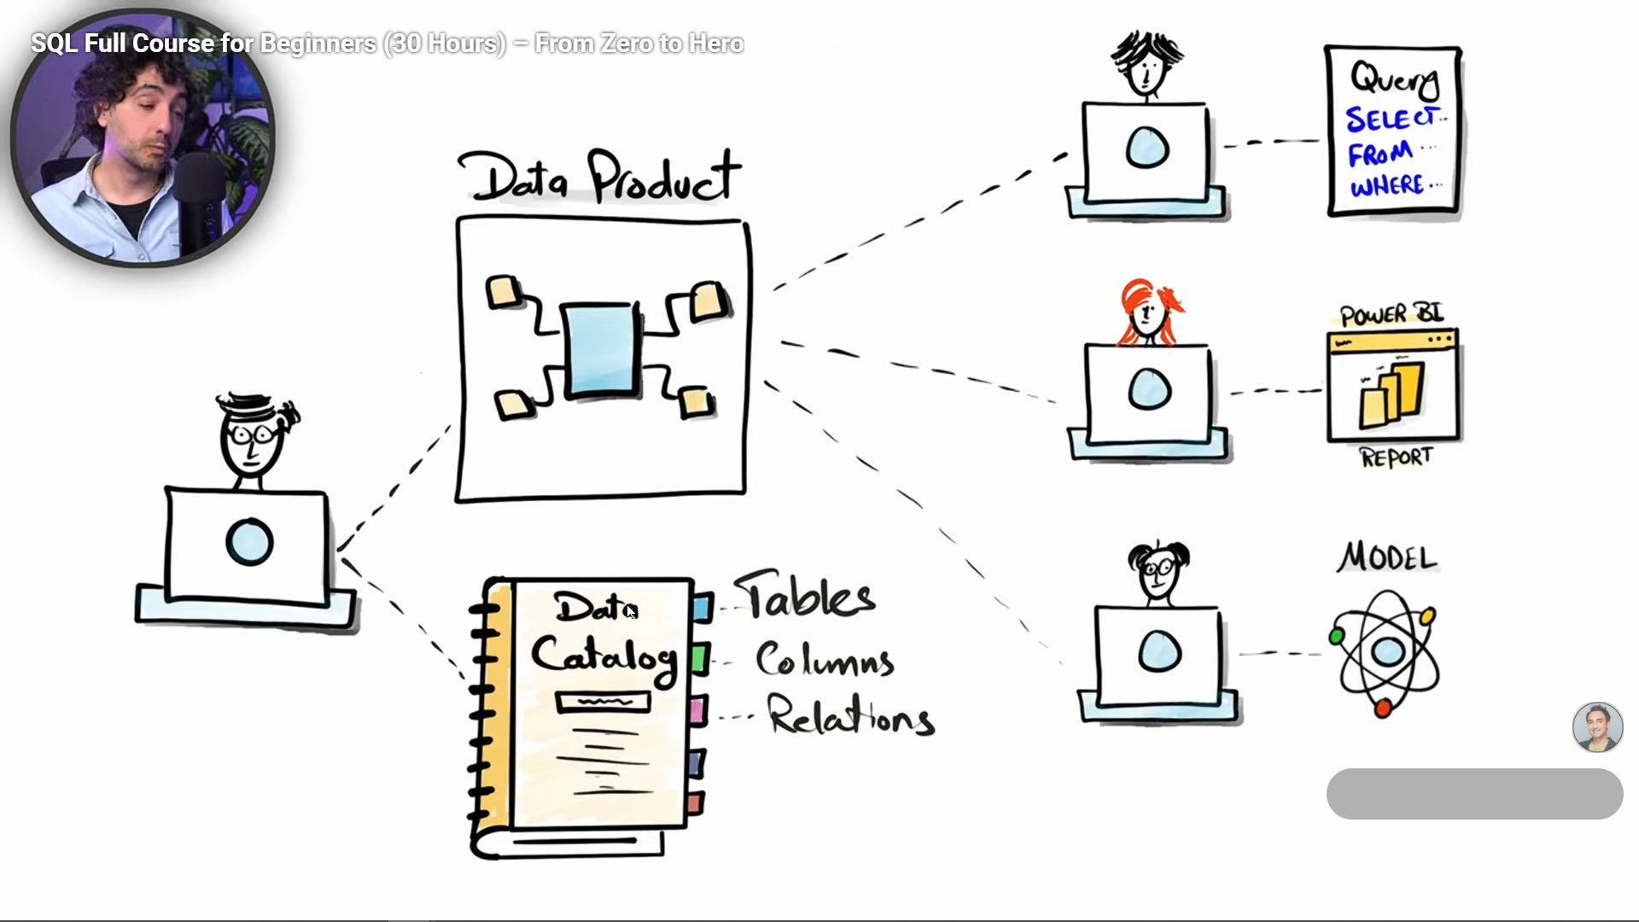

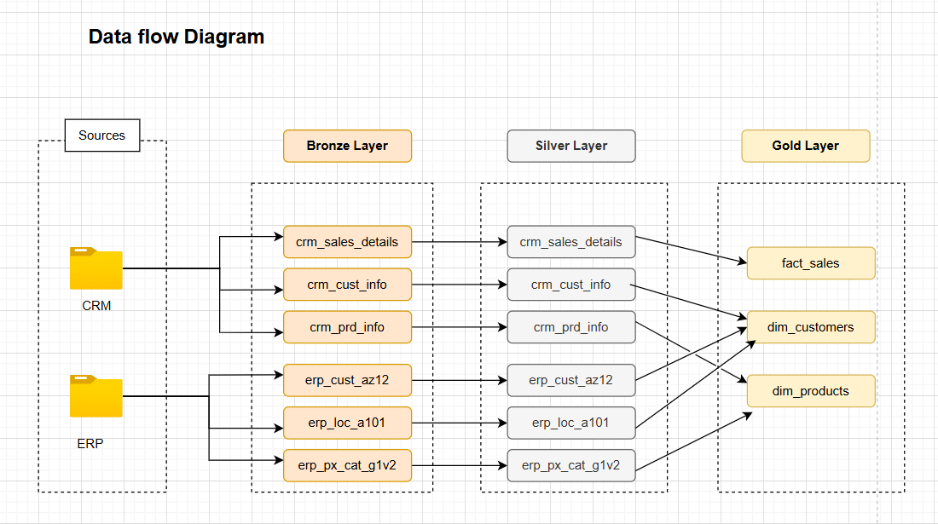

The end.